**Project Proposal**

**Navjot Singh Virk X13112406, 4th Year Software Development Stream**

**National College of Ireland**

***Project Name:*** Meeting Room Pro

***Github:*** <https://github.com/Virksaabnavjot/MeetingRoom-Pro>

# Objective

The objective of the project is to develop an iOS application, that allows its users to find, review and book meeting rooms. The user can search meeting rooms, upload images of the room which will be available on the app for other users for assistance, see where the meeting room is in the building on the map. The application will allow users ease of use and help quickly find info on their desired/selected meeting room like equipment available in that room etc., and additional information like which floor and my meetings tab which allows the users to see all his/her meetings and the also allows the users to create meetings and save in the phone calendar.

**Map Feature**

Using Apple maps (MapKit) and the coordinates of buildings and meeting rooms. The building will be drawn on the map as a polygon and the meeting room as a point on the map along with the current location of the user.

**Camera Feature**

The users will be given an option to take photo through the app or choose an image from phone gallery and upload it to the application gallery.

**Gallery Feature**

A gallery of photos of the room and equipment available, the application will allow the user to upload images which will be available in gallery for other users to view.

**Review Feature**

This feature will allow the user to review the meeting room and the room ratings will be available for other users to see.

**Geo Location Feature**

The app will use geo-spatial data to display buildings and meeting rooms on the map and when a user is in a certain radius close to the meeting room. The user will receive notifications with approx. distance left from the meeting room.

And the functionality to disable this feature will also be given.

If the user has a meeting booked in a meeting room and if their phone is not within a certain radius to the meeting room, the user will receive a reminder notification. Also, the user will receive a reminder few minutes say 10 minutes before the meeting starts.

# Background

During my work placement at SAP SE, I was engaged in several meeting from my induction to my farewell meeting, there were more than 50 meetings, from team meetings to global team meetings, intern meetings and HR meetings, to employee farewell meetings which I was part of in the course of 7 months of internship.

And number one issue was finding the meeting room due to big size of the buildings, if the meeting room was close enough to my desk, it was easy enough to find the meeting room but the problem used to arise when the meeting rooms were on different floors, even different wing of the same floor and the problem was big when trying to find a meeting room on another building and some fancy names to the meeting rooms didn’t make much sense at all and the icing on the top if you are short on time i.e. have consecutive meetings to attend and the only solution available was to ask you collages if they didn’t know run towards the reception and they would show you a floor plan which sometimes didn’t made sense and overall experience in finding meeting rooms was not up to the standards to which it could be achieved.

I started some research and found other employees were facing the same issues and were just limited to using meeting rooms near their offices due the hassle of finding meeting rooms, after talking to people the user research findings were not just the interns who felt this pain, some of the very senior employees which were there for many years didn’t know were some of the meeting rooms were and since SAP is multinational company, there were always employees from different location which travelled to attend meetings and had very hard time finding the meeting room and first have to go to facilities department and the facilities member would manually assist wherever this process can be automated i.e a simple to use to application could solve this problem.

Hence, there is were the idea for the application is developed from but it is not just limited to corporate world the application can be put to use in universities and college with minor changes.

# Technical Approach

Mobile App / Client Application

The Client application, will be developed using apple’s new programming language : Swift 3 <https://developer.apple.com/swift/>



Reasons for Using Swift

Its fast, open-source, have to write less code and get more work done, its interactive and another motivation for using Swift for this project is, I have done some swift during internship and it’s a new language to me and I would like to learn it more in depth while working on this project.

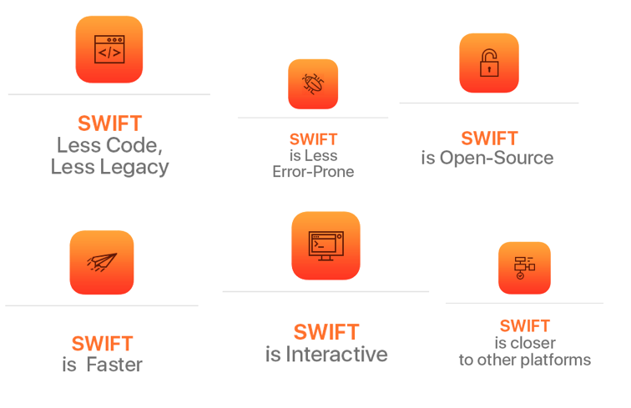

and using Xcode 8 IDE <https://developer.apple.com/xcode/>



**XCODE**

**Xcode** is an integrated development environment (IDE) containing a suite of software development tools developed by Apple for developing software for macOS, iOS, WatchOS and tvOS.

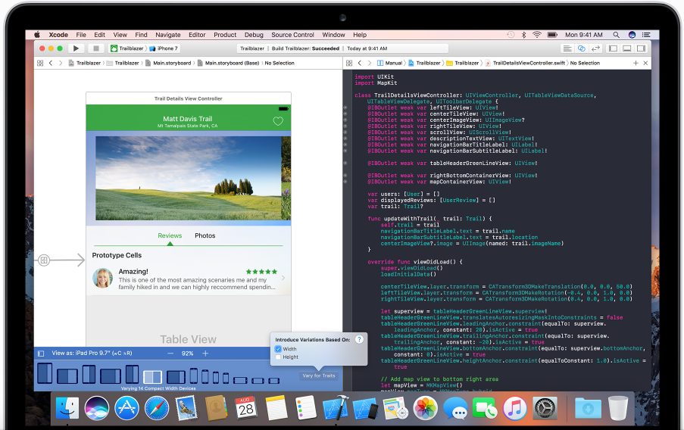

The mobile application will run on IOS devices including iPhone and iPads.

Backend

a JavaScript based Web service will be developed which will expose the data for the use of client app.

**On database side**: Geo-spatial features of MySQL/SAP Hana Spatial will be used.

**What is SAP Hana Spatial?**

Hana Spatial is a feature of SAP Hana

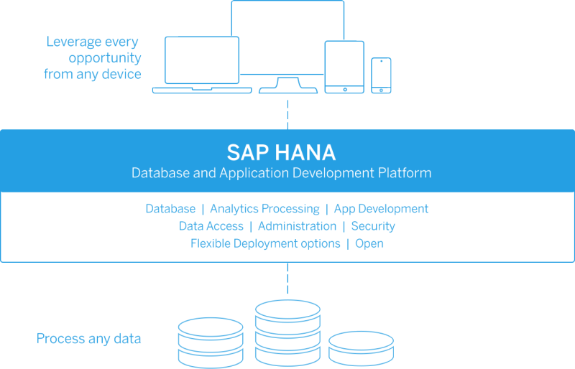

Why Hana Spatial?

HANA Spatial delivers the ability to store and process geospatial data types like ST_POINT, ST_GEOMETRY etc. Which allows to store co-ordinates for the buildings and meeting rooms for this project.

# Special resources required

This project doesn’t necessarily need any special resource, wherever the project can be taken to a different level by implementing beacons for indoor navigation or sensors to track presence of people in meeting rooms.

# Project Plan

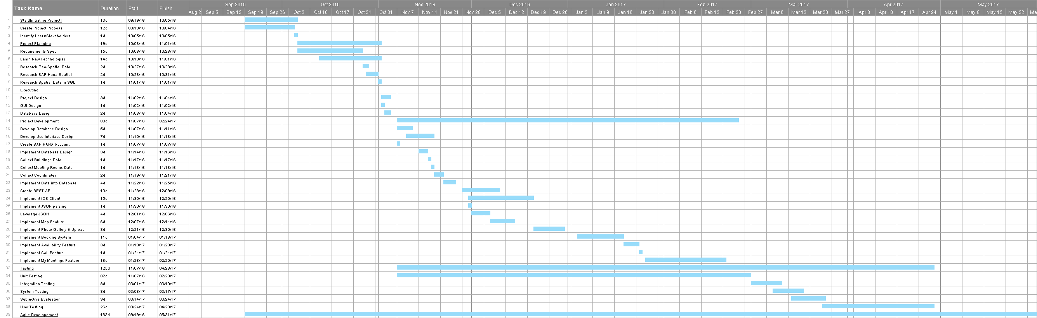

Zoom View of Gantt Chart

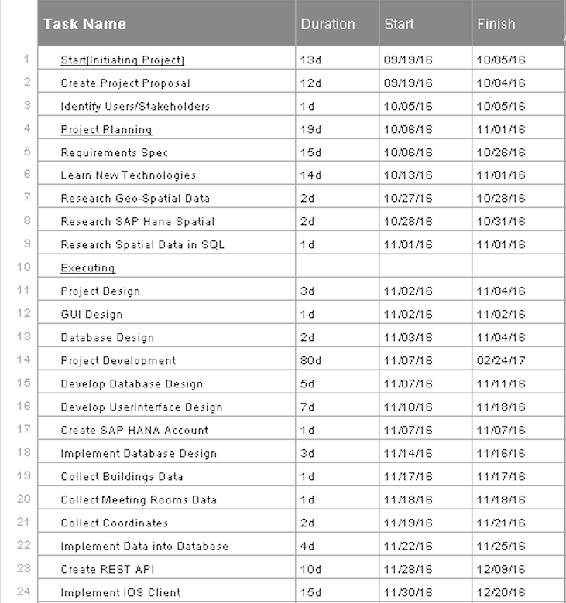

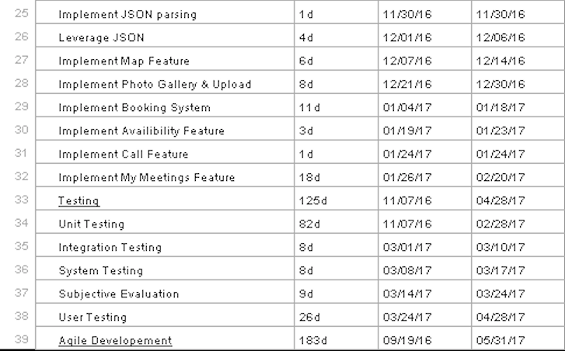

# Technical Details

Implementation languages and principle libraries

Frontend / Client Side:

Swift 3 <https://developer.apple.com/swift/>

Core libraries:

* Foundation
* CoreLocation
* UIKit
* CoreLocation
* MapKit

And possibly some HTML and CSS.

3rd Party libraries

SwiftyJSON.swift <https://github.com/SwiftyJSON/SwiftyJSON>

Server Side:

SAP Hana Spatial database

JavaScript

MySQL

Possibly REST Architecture

# Evaluation

For Unit testing of Swift - XCTest Unit Testing framework.

For unit testing of Javascript – QUnit or Jasmine Javascript Testing Framework.

System Testing – will be performed on entire system in the context of Functional requirements and system requirements

Integration Testing – Continued research, no decision made on this at this time.

How will the system be evaluated by the end user?

* Discussion with College Staff, Corporate Organisations
* College students discussing the app and its features.
* By getting feedback on prototype.

# Proposed Supervisor

Cristina Muntean